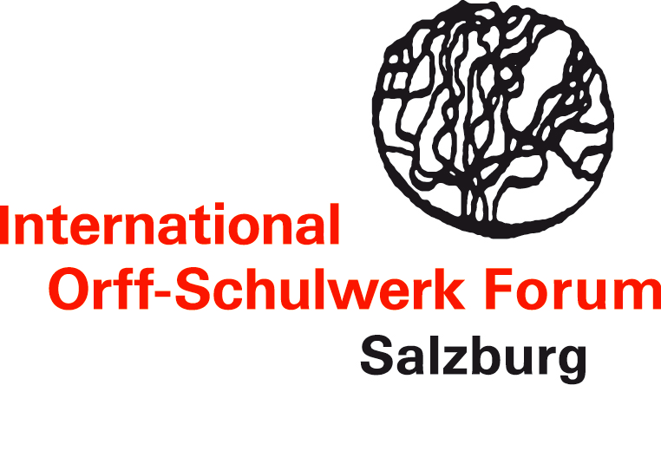

"Avoiding plagiarism": guidelines for the ethical use of sources in teacher education courses and publications

With this document, the International Orff-Schulwerk Forum Salzburg intends to provide some general guidelines about the respectful use of other people's ideas and practices in the context of teacher education courses and publications.

As a premise, it must be stated that the IOSFS actively promotes the progress of Orff-Schulwerk-related pedagogical knowledge and practice. In this sense, it seems absolutely desirable to borrow, imitate, assemble, transform, re-interpret, re-contextualise or re-purpose existing materials and ideas of others. This is in itself a fair and critically important practice, which contributes to spreading and further developing the Orff-Schulwerk as a dynamic pedagogical concept.
A necessary condition, however, is that we acknowledge the sources on which we base our work, both in oral communications (e.g. during the teacher training) and in any kind of written form (handouts or publications). Otherwise, we are committing plagiarism.

Plagiarism is defined as the wrongful appropriation of somebody else's intellectual and (in our case) pedagogical property. In the academic world, plagiarism is considered a form of fraud or theft and is severely punished.
In the following, we establish some basic rules and a code of conduct as to how teachers, teacher educators and authors of publications should behave when dealing with somebody else's ideas.

As a teacher you are strongly encouraged to apply, use and adapt ideas you have acquired through colleagues, readings or participation in teacher education initiatives. You should actively acknowledge the sources of your work, even if you are "just" communicating with parents in the context of a performance. The underlying principle for good practice is to publicly value and credit the work of colleagues.

As a teacher educator you have a much greater responsibility. In the perspective of intellectual integrity and honesty, you should attribute the ideas/materials you are using to the sources from which you have drawn them (and possibly ask for authors' permission directly).

Both in oral communication and especially in your handouts, be very rigorous in referencing the origin of the pieces, arrangements, learning processes, methods or concepts that you are offering to the participants. These measures will reinforce your work as well grounded and connected to a wider pedagogical community.

As an author of publications (blog posts, articles in journals and magazines, chapters, books, or any other kinds of written contributions), you must properly acknowledge your sources according to the rules and prescriptions of academic institutions. Plagiarism is in such cases a very serious violation of copyright laws and is condemnable as an illegitimate and unacceptable practice.

In our community of practice, we do want to share ideas and visions. We need it in order to construct new culture by building on existing culture.
For the sake of the internal and external credibility of Orff-Schulwerk, we need to maintain high standards of academic integrity and to avoid plagiarism. We cannot allow anybody to present someone else's work as their own. We want, instead, to give due credit to our sources in an adequate and ethical way.

The Board of the International Orff-Schulwerk Forum Salzburg
July 22nd, 2018

